Introduction: Need to fix citations

Atherosclerosis is a chronic inflammatory process resulting in plaque buildup in the artery walls, which underlies cardiovascular diseases (CVDs) including coronary artery disease, myocardial infarction, and stroke. Roughly 25% of these patients do not display any of the major risk factors [3, 4, 26]. The prevalence of lipid risk factors such as elevated levels of sTg and cholesterol among CVD patients is only slightly higher than in elderly subjects who do not develop CVD [27, 28]. While the current lipid management techniques may alleviate some proportion of CVD, it is important to also identify inflammatory risk predictors and manage inflammation and endothelial dysfunction.

Hypertriglyceridemia (HTG), elevated fasting sTG, is one of the most prevalent risk factors associated with CVD. Dietary lipids packaged into triglycerides and cholesterol, which circulate in very low-density lipoprotein (VLDL) in the fasting state and, VLDL and chylomicrons in the postprandial state and are together called triglyceride rich lipoprotein (TGRL). TGRL are dynamic particles that vary in size, composition and number, and are reflective of the diet, and metabolic conditions such as diabetes and dyslipidemia of an individual [31-33]. Several studies have recently associated an inflammatory potential induced by TGRL (Add citations). This motivated us to investigate the inflammatory potential and composition of TGRL.

Further, a high fat meal challenge has been utilized in recent studies to gain better insights into an individual’s metabolic responsiveness [29, 30]. The postprandial state induces low grade inflammation, characterized by increased circulation of cytokines including TNF-α and ApoB-containing lipoproteins, elevated expression of cell adhesion molecules (CAMs) such as VCAM-1 contributing to endothelial dysfunction, and increased preferential recruitment of leucocytes. This state is exacerbated and prolonged by a high fat meal. We have consistently observed that after a high fat meal, serum-derived TGRL isolated from a cohort of human subjects ranging from heathy to HTG (fasting sTg >150), primed either a pro- or anti- atherogenic response in HAEC activated by low doses of TNF-α [5-7]. An atherogenic response was marked by the capacity of TGRL to upregulate TNF-α induced VCAM-1 expression and subsequent monocyte arrest on inflamed HAEC. This response reflects on an individual’s ability to cope with a high fat meal correlated with lipid indicators such as high sTg, and markers of abdominal obesity [14]. In addition, we determined that the TGRL induced pro-atherogenic response was mediated through ER stress signaling leading to upregulation of interferon regulatory factor-1 (IRF-1), which is a regulator of TNF-α induced VCAM-1 transcription (Figure 2) [5]. We have yet to determine how changes in the composition of TGRL in response to a meal drives the variation in endothelial inflammatory response via the ER stress response.

It is known that the biochemical composition of pp-TGRL directly influence endothelial uptake and function [35]. We have shown that the difference in the inflammatory response correlated with particle composition such as particle triglyceride, cholesterol, ApoCIII and ApoE content. Preliminary data suggests that pro-atherogenic TGRL are enriched in PUFA, and depleted in saturated and monounsaturated fatty acids. PUFAs are oxygenated to produce bioactive species called oxylipins, which have shown to mediate inflammatory responses [19]. The three-important enzymatic metabolic pathways (Figure 3) involved in PUFA oxygenation include: Lipoxygenase (LOX), cyclooxygenase (COX) and Cytochrome P450_epoxygenase (CYP_epoxy). LOX release alcohols and ketones, which are generally considered pro-inflammatory, while epoxides released from the CYP epoxy pathways are considered anti-inflammatory. COX releases prostaglandins which are generally pro-inflammatory and anti-inflammatory prostacyclins. Oxylipins are esterified in TGRL and can be released through lipolysis by lipoprotein lipase in ECs. Rabbits on a high-fat diet developed plaques that were enriched in LOX derived pro-inflammatory oxylipins such as 13 HODE, 9 HODE, 12 HETE, 12,13 TriHOME. 9 HODE, 13 HODE and 11 HETE, were also elevated in the plasma of these rabbits [36]. Further, there were stark differences in oxylipin profiles in lipolyzed VLDL pool obtained from obese HTG rats in comparison to wild type [37]. Additionally, n-3 supplementation in humans has shown to shift the oxylipin distribution in lipoproteins and plasma toward enrichment in n-3 derived oxylipin, which is correlated to lower s-TG levels and better cardiovascular health [20]. However, the role of diet in inducing changes in PUFA profile in the TGRL to directly affect endothelial lipid metabolic and inflammatory responses endothelium is unknown.

Emphasize TGRL (assembled elsewhere) as means to deliver oxylipins to peripheral tissue (here endothelium) where they can mediate local inflammatory response

Our objectives were to 1) determine the changing oxylipin profile in TGRL in response to a metabolic challenge (the high fat test meal), 2) identify the changes in composition and abundance that correlate most strongly with the inflammatory capacity of TGRL, and 3) directly link these changes to ER-mediated endothelial inflammation measured on-chip.

We hypothesized that the relative abundance of PUFA and their oxygenated metabolites (oxylipins) in postprandial TGRL varies in proportion to an individual’s overall metabolic status, and correlates with a distinct ER stress-mediated inflammatory response in endothelium.

Method:
N=39 subjects were consented in accordance with the UC Davis IRB protocol. The subjects varied from normal lipidemic to hyperlipidemic subjects with characteristics of metabolic syndrome(Table1). Subjects were recruited without restriction to gender, race, or socioeconomic status. Exclusion criteria include subjects with kidney disease, liver disease, untreated thyroid dysfunction and ongoing hormone replacement therapy, intake of omega-3 supplementation, lipid lowering medications (i.e. statins), and excessive or prolonged use of alcohol, nonsteroidal anti-inflammatory drugs, and caffeinated beverages. A high saturated fatty acid meal was administered to the subjects, and blood samples were collected after an overnight fast and 3.5 hrs after the high fat meal. Serum was isolated and TGRL were collected from subjects before and after the high fat meal. Human aortic endothelial cells (HAEC) were incubated with postprandial-TGRL (10 mg/dl ApoB) for 4 hrs in the presence of TNF-alpha (0.3 ng/ml). VCAM-1 and ICAM-1 expressions were measured in HAEC in response to TGRL. To account for day to day cell variability % change of VCAM-1 and ICAM-1 expression from baseline change in TNF-alpha (0.3ng/ml) is measured.
Composition of the meal:
Macronutrient | Value |  | Daily Value (%)
Energy (Kcal) | 1198.0 | 59.9
Total lipid (g) | 67.5 | 103.8
Carbohydrate (g) | 106.2 | 35.4
Protein (g) | 44.9 | 89.7
SFA (g) | 21.1 | 105.3
MUFA (g) | 26.0
PUFA (g) | 11.8
Trans (g) | 1.1
Cholesterol (mg) | 508.0 | 169.3

Table1: Demographics, lipid and metabolic characteristics of subjects before and after a high fat meal
 | Fasting |  | Postprandial | p-value
Age
  39.6 +/- 16.6
BMI (Kg/m2)
  25.8 +/- 3.6
Waist circumference (in) |  | 34.1 +/- 4.3
WHR
  0.9+/-0.1
Systolic |  | 114.8+/- 8.2
Diastolic
  72.3+/- 9.3
Metabolism-Non-lipid
Glucose
  86.2 +/-7.4
  80.6+/- 11.1
Lipid indicators
HDL (mg/dl)
  58.4 +/-17.3
  55.56+/- 16.62
LDL (mg/dl)
  128.6 +/- 65.2
  100.6+/ 28.8
Chol:HDL-C |  |  | 4.0 +/- 1.7
  3.8 +/- 1.6
TG (mg/dl)
  100.4+/- 62.0
  205.0 +/- 139.4
ApoB (mg/dl)
  91.3 +/- 41.3
  91.2 +/- 41.1
Non-HDL Chol (mg/dl)
  148.8 +/- 69.4
  149.3 +/- 70.7
TC (mg/dl)
  207.1 +/- 69.7
  204.8 +/- 70.8
TG:HDL-C
  2.1 +/- 1.9
  4.4 +/- 3.8

Mean +/- SD N=39 (26 male and 13 female)

Results:
We observed that PP-TGRL primed a distinct pro- or anti-atherogenic response marked by increase or decrease of VCAM-1 expression from baseline TNF-alpha. Table 2 summarizes the correlation coefficients of the serum biomarkers with the %change of VCAM-1 expression. Particularly the change in VCAM-1 expression correlated with PP-TG, change in triglycerides in response to the meal (b), Chol:HDL-C (d) and TG:HDL-C ratios (c) (Figure1). Additionally the VCAM-1 expression was higher in subjects with Chol:HDL-C and TG:HDL-C ratio of ratio of 4 or higher. In contrast ICAM-1 expression did not correlate with any of these biomarkers.

Table 2: Correlation of subject characteristics and TGRL induced VCAM-1 expression
Factor | Pearson correlation coefficient | P-value  (two tailed) | R²
Waist circumference | -0.02 | 0.89 | 0.00
Body mass index | 0.22 | 0.17 | 0.05
Change in triglyceride (PP-F) | 0.32 | 0.05 | 0.10
PP TG to ICAM-1 | -0.07 | 0.73 | 0.01
Fasting
Triglycerides | 0.25 | 0.13 | 0.06
Total cholesterol | 0.18 | 0.27 | 0.03
LDL-C | 0.20 | 0.24 | 0.04
HDL-C | -0.18 | 0.27 | 0.03
Apo-B | 0.23 | 0.15 | 0.05
Chol: HDL-C | 0.32 | 0.05 | 0.10
TG:HDL-C | 0.23 | 0.16 | 0.05
Glucose | -0.19 | 0.26 | 0.03
Non-HDL | 0.23 | 0.17 | 0.05
Postprandial
Triglyceride | 0.31 | 0.05 | 0.10
Total cholesterol | 0.13 | 0.45 | 0.02
LDL-C | 0.26 | 0.26 | 0.07
HDL-C | -0.26 | 0.11 | 0.07
ApoB | 0.19 | 0.25 | 0.04
Chol:HDL-C | 0.33 | 0.04 | 0.11
TG:HDL | 0.32 | 0.05 | 0.10
Glucose | -0.29 | 0.08 | 0.08
Non HDL | 0.21 | 0.21 | 0.04

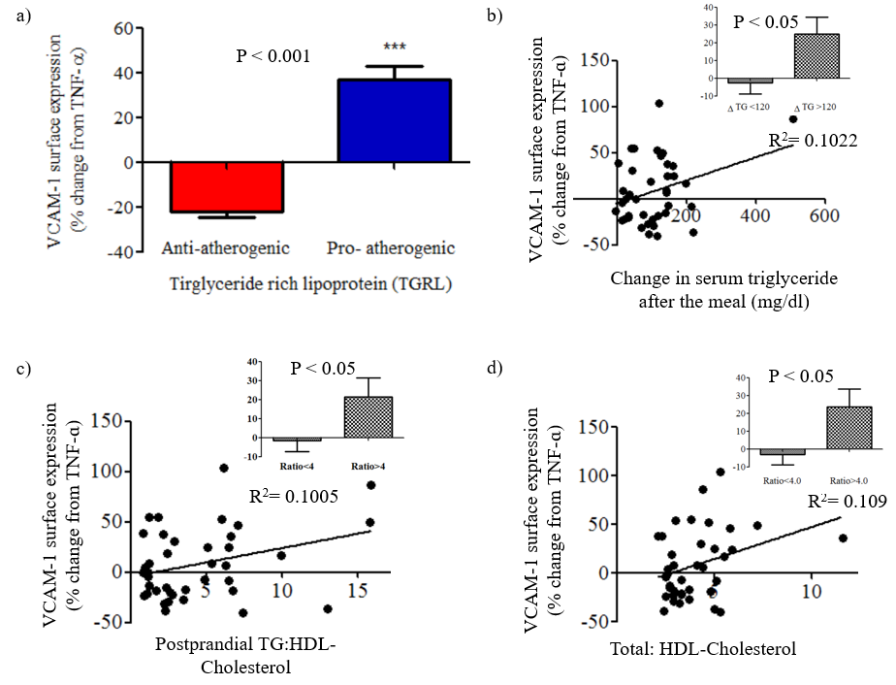

Need legend for above:
Is part A for all 39 subjects?
Color scheme in A should be reversed
Explain binning in insets

Method:
The data were log2 transformed, which had the effect of producing more normal distributions and stabilizing the variance across analytes. We performed a paired t-test (n=10) to compare the differences in abundance of PUFAs and oxylipins in response to the high fat test meal.
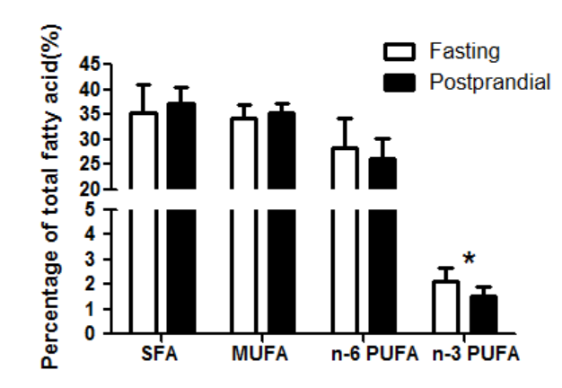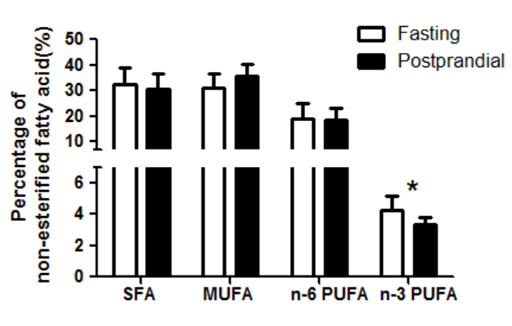

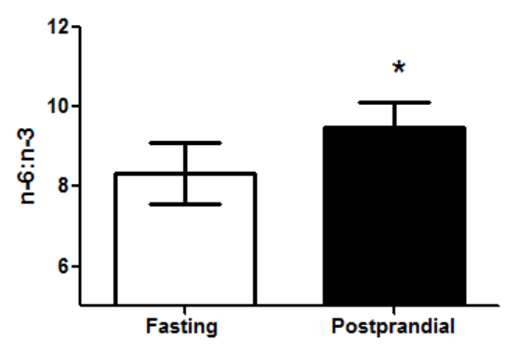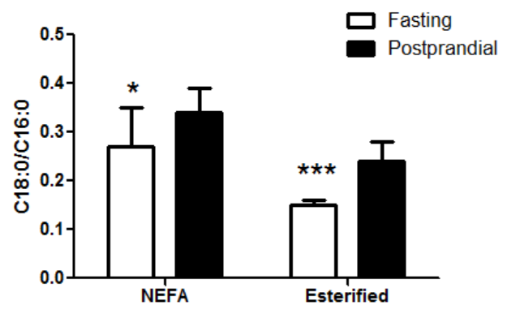

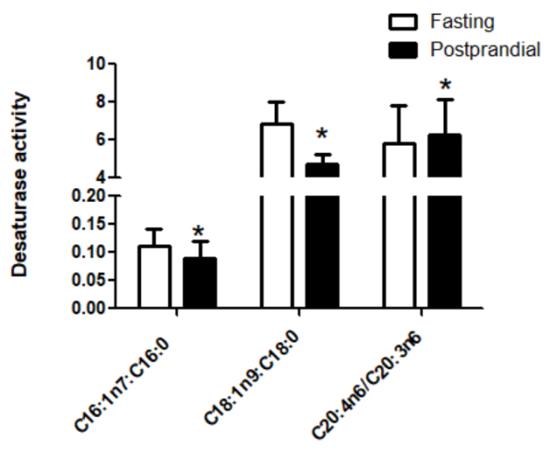
Desaturase activities have been correlated with metabolic syndrome:
Δ7 desaturase- C16:1n7/ C16:0
Δ9 desaturase- C18:1n9/ C18:0
Δ5 desaturase- C20:4n6/ C20:3n6
C18:0/C16:0 – Elongation activity ELOV6
Result:
- N-3 PUFA were reduced in both EFA and NEFA pools in TGRL across all subjects in response to the meal
- This had the effect of increasing the overall ratio of omega-6: omega-3 PUFA

- Postprandial changes in TGRL reflected fatty acid metabolism activity (Δ7, Δ9, Δ5, and elongation activity). Need to read more on the role of these metabolic pathways and their association with MetS.

Method:
The data were log2 transformed. We performed a paired t-test (n=10) to compare the differences in abundance of PUFA and oxylipins in response to the high fat test meal. Further, we performed this comparison within each subset of the samples (pro (n-5), anti (n=5)). P-values were corrected for false discovery rate. A FDR of 10% was considered significant.

Table3 Esterified fatty acid composition in fasting and postprandial TGRL of all subjects. P-values are from paired t-test adjusted for false discovery rate (FDR)

Fatty Acid |  |  |  | Common name |  |  | Fasting |  |  |  |  |  | Postprandial |  |  | P-values
Saturated fatty acid
%C20:0 # |  | Arachidic acid |  |  |  |  | 0.04% +/-0.02% |  |  |  |  |  | 0.11% +/- 0.05% |  |  | 9.17E-04
%C18:0 # |  | Stearic acid |  |  |  |  | 4.28% +/- 0.55% |  |  |  |  |  | 6.50% +/- 0.86% |  |  | 3.77E-03
Monounsaturated fatty acid
%C20:1n9 # |  | Eicosenoic acid |  |  |  |  | 0.16% +/-0.03% |  |  |  |  |  | 0.22% +/- 0.04% |  |  | 0.01
%C16:1n7 |  | Palmitoleic acid |  |  |  |  | 3.13% +/-1.06% |  |  |  |  |  | 2.55% +/- 0.99% |  |  | 0.01
%C16:1n7 |  | Palmitoleic acid |  |  |  |  | 521.17 +/- 382.18 |  |  |  |  |  | 205.00 +/- 103.89 |  |  | 0.08
%C18:1n9 |  | Oleic acid |  |  |  |  | 28.68% +/-2.28% |  |  |  |  |  | 30.09% +/- 1.80% |  |  | 0.09
Polyunsaturated fatty acid
Omega-6 PUFA
%C20:2n6 | Eicosadienoic acid |  |  |  |  | 0.20% +/- 0.04% |  |  |  |  |  |  | 0.25% +/- 0.05% |  |  | 0.02
%C20:3n6 | Dihomo gamma linoleic acid |  |  |  |  | 0.64% +/- 0.19% |  |  |  |  |  |  | 0.48% +/- 0.13% |  |  | 0.04
%C20:4n6 | Arachidonic acid |  |  |  |  | 3.40% +/- 0.60% |  |  |  |  |  |  | 2.85% +/- 0.68% |  |  | 0.04
C20:3n6 | Dihomo gamma linoleic acid |  |  |  |  |  | 117.63 +/- 119.82 |  |  |  |  |  | 40.51 +/- 22.61 |  |  | 0.08
C18:3n6 | Gamma linoleic acid |  |  |  |  |  | 79.24 +/- 88.65 |  |  |  |  |  | 26.72 +/- 15.90 |  |  | 0.08
C20:4n6 | Arachidonic acid |  |  |  |  |  | 592.38 +/- 510.77 |  |  |  |  |  | 240.61 +/- 124.53 |  |  | 0.09
Omega-3 PUFA
% C22:5n3 # |  | Docosapentaenoeic acid |  |  |  |  | 0.47% +/- 0.12% |  |  |  |  |  | 0.32% +/- 0.07% |  |  | 0.04
%C22:6n3 |  | Docosahexaenoic acid |  |  |  |  | 1.16% +/- 0.44% |  |  |  |  |  | 0.84% +/- 0.31% |  |  | 0.06
%C20:5n3 # |  | Eicosapentaenoic acid |  |  |  |  | 0.38% +/- 0.19% |  |  |  |  |  | 0.30% +/- 0.16% |  |  | 0.06
C22:6n3 |  | Docosahexaenoic acid |  |  |  |  | 175.51 +/- 130.02 |  |  |  |  |  | 70.78 +/- 52.99 |  |  | 0.06
C22:5n3 |  | Docosapentaenoeic acid |  |  |  |  | 82.83 +/- 81.05 |  |  |  |  |  | 25.39 +/- 10.97 |  |  | 0.06
C20:5n3 |  | Eicosapentaenoic acid |  |  |  |  | 76.76 +/- 92.16 |  |  |  |  |  | 24.39 +/-14.91 |  |  | 0.08
C20:4n3 |  | Eicosatrienoic acid |  |  |  |  | 8.65 +/- 8.71 |  |  |  |  |  | 3.07 +/- 1.18 |  |  | 0.10
Oxylipins
Diols (CYP Pathway) |  |  |  |  | Parent fatty acid
9,10-DiHODE# |  | Alpha linoleic acid (n-3) |  |  |  |  |  |  |  | 0.25 +/- 0.24 |  |  | 1.32 +/- 0.91 |  |  | 0.01
15,16-DiHODE # Alpha linoleic acid (n-3) |  |  |  |  |  |  | 1.97 +/- 1.63 |  |  |  |  |  | 5.79 +/- 3.43 |  |  | 0.01
12,13-DiHOME # Linoleic acid (n-6) |  |  |  |  |  |  | 2.70 +/- 2.81 |  |  |  |  |  | 8.16 +/- 4.92 |  |  | 0.03
9,10-DiHOME # Linoleic acid (n-6) |  |  |  |  |  |  | 2.81 +/- 3.33 |  |  |  |  |  | 8.24 +/- 5.76 |  |  | 0.04
14,15-DiHETrE |  | Arachidonic acid (n-6) |  |  |  |  | 0.28 +/- 0.17 |  |  |  |  |  | 0.12 +/- 0.05 |  |  | 0.06
11,12-DiHETrE |  | Arachidonic acid (n-6) |  |  |  |  |  |  | 0.55 +/- 0.41 |  |  |  | 0.23 +/- 0.11 |  |  | 0.08
17-HDoHE |  | Docosahexaenoic acid (n-3) |  |  |  |  |  |  | 26.71 +/- 19.9 |  |  |  | 13.53 +/- 15.24 |  |  | 0.09

Though overall classes of fatty acids (SFA, MUFA, n-6 PUFA) did not change, there were significant changes in specific FAs postprandial: enrichment in C18:0 and C20:0, general depletion in certain MUFA and PUFA
Overall PUFA tend to go down, more so for n-3
Diols (CYP/sEH metabolites) tend to increase postprandial
Pro specifically associated with enrichment in C18:0, and C20:0, decrease in DPA and EPA, enrichment in both n-3 and n-6 oxylipins (notably diols of LA and ALA)

Table 4 Non-esterified fatty acid composition in fasting and postprandial TGRL across all subjects. P-values are from paired t-test adjusted for false discovery rate (FDR)
Fatty acid Common name |  | Fasting |  |  |  |  | Postprandial |  |  | P-value
Monounsaturated fatty acid
%C18:1n9 | oleic acid | 24.81% +/- 4.79% |  |  |  |  | 30.03% +/- 4.27% |  |  |  | 0.09
%C16:1n7 | Palmitoleic acid | 3.29% +/- 1.01% |  |  |  |  | 2.67% +/- 0.65% |  |  |  | 0.08
Poly unsaturated fatty acid
Omega-6 PUFA
% C18:3n6 | dihomo gamma linoleic acid |  | 0.43% +/- 0.14% |  |  |  |  | 0.27% +/- 0.10% |  |  |  | 0.06
C183n6 | dihomo gamma linoleic acid |  | 65.21% +/- 45.68% |  |  |  |  | 30.11% +/- 8.86% |  |  |  | 0.06
%C20:4n6 | Arachidonic acid |  | 1.82% +/- 1.15% |  |  |  |  | 0.94% +/- 0.32% |  |  |  | 0.10
Oxylipins
Mid chain alcohol Parent fatty acid
9-HOTE # Alpha linoleic acid |  |  |  | 0.40 +/- 0.41 |  |  | 1.21 +/- 0.75 |  |  |  | 0.01
9-HODE # Linoleic Acid |  |  |  |  | 6.44 +/- 6.31 |  | 19.59 +/- 14.83 |  |  |  | 0.02
5-HEPE Eicosapentaenoic acid |  |  |  |  | 2.51 +/- 2.76 |  | 0.69 +/- 0.54 |  |  |  | 0.02
5-HETE Arachidonic acid |  |  |  |  | 3.76 +/- 5.03 |  | 0.95 +/- 0.23 |  |  |  | 0.08
13-HOTE Alpha linoleic acid |  |  |  |  | 3.02 +/- 2.06 |  | 6.97 +/- 2.53 |  |  |  | 0.09
13-HODE Linoleic acid |  |  |  |  | 9.35 +/- 7.48 |  | 15.50 +/- 8.57 |  |  |  | 0.09
Diols
12_13-DiHOME # Linoleic acid (n-6) |  | 0.61 +/- 0.84 |  |  |  |  | 2.68 +/- 2.14 |  |  |  | 0.02
15_16-DiHODE # Alpha linoleic acid (n-3) |  | 1.48 +/- 2.58 |  |  |  |  | 3.85 +/- 2.51 |  |  |  | 0.04
9_10-DiHOME Linoleic acid (n-6) |  | 0.58 +/- 1.00 |  |  |  |  | 1.47+/- 1.76 |  |  |  | 0.08
5_6-DiHETrE Arachidonic acid (n-6) |  | 0.84 +/- 1.07 |  |  |  |  | 0.22 +/- 0.08 |  |  |  | 0.08
Ketone
9-KODE Linoleic acid (n-6) |  | 6.64 +/- 4.44 |  |  |  |  | 12.03+/- 3.73 |  |  |  | 0.06
Epoxide
12,13-EpODE Alpha linoleic acid (n-3) |  | 0.34 +/- 0.41 |  |  |  |  | 0.78 +/- 0.43 |  |  |  | 0.08

#- Differences in the limited pro-TGRL samples (n-5)

The non-esterified pool revealed few changes in specific FAs postpradial, but a distinct oxylipin signature revealing general enrichment in mid chain alcohols, diols and ketones
Pro in particular enriched in LOX (and CYP/sEH) metabolites of LA and ALA

Results:
- Saturated fatty acid (arachidic and stearic acids) are most significantly increased in esterified pool in response to the meal. Significant depletion in several abundant n-6 and n-3 PUFA.
- In the esterified pool diols were the only group of oxylipins that were observed to be affected due to the meal. No significant changes were observed in mid chain alcohols, ketones, epoxides, prostaglandins and triols in the esterified fatty acids.
- In contrast, in the NEFA pool, there was enrichment in representatives of several oxylipin classes postprandially
- When the subsets of pro- and anti- TGRL were analyzed for fasting to PP changes, there were no significant differences in anti-TGRL in response to the meal. Analysis of pro-TGRL revealed enrichment in representatives from several oxylipin classes--a subset of the differences across all samples. Notable were products of LA and ALA metabolism through CYP/sEH and to a lesser extent LOX.

A hierarchical clustering of samples was performed. Figure represents the sample clustering.
Which features were used, etc?
This analysis probably should be moved up in the sequence, i.e. before individual analytes.
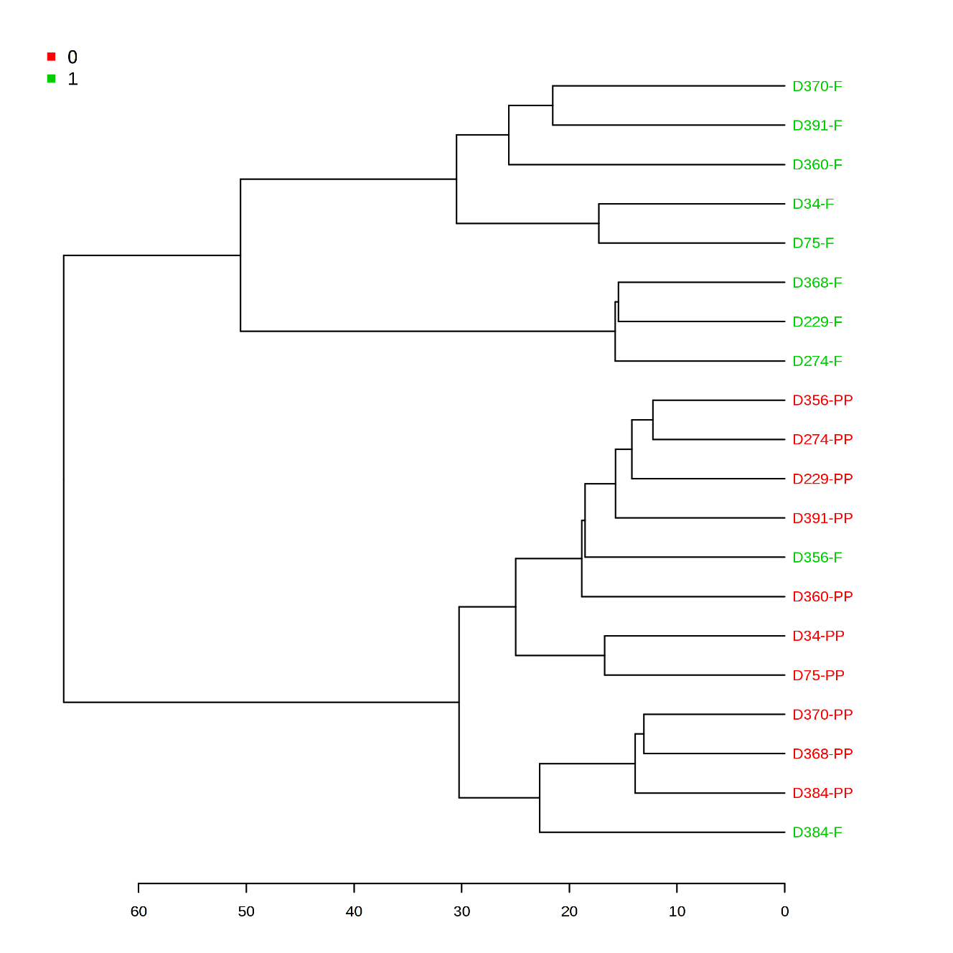
Anti-
D229-F | D360-F | D384-F | D391-F | D75-F

Pro-
D274-F | D34-F | D356-F | D368-F | D370-F

In general there is a clear distinction between the fasting and postprandial samples, reflecting the impact of the meal on TGRL composition
There appear to be no pattern to pro- and anti- samples here which is somewhat surprising. Perhaps a more limited set of metabolites would yield a different result, as per PCA analysis?

Pathway analysis:
MetPA performed an over expression test to measure if the set of compounds changing in response to the meal is from a pathway more than chance. We performed a hypergeometric test.
Uses information from KEGG and HMDB.
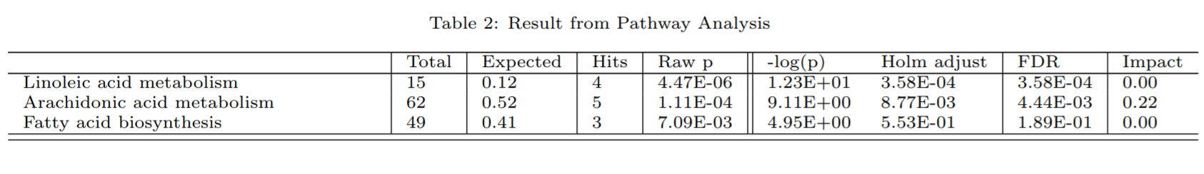

This analysis revealed enrichment in LA, AA metabolism and FA biosynthesis in our data set.

Overall, what do we learn from this analysis?:
There are consistent changes in TGRL postprandially that reflect the nature of our high fat meal.
These changes overall include depletion in n-3 PUFA and increase in the n-6:n-3 ratio, enrichment in certain FAs and oxylipins that reflect enhanced LA/ AA metabolism and FA biosynthesis.

(More on the distinction between the pro- and anti- samples and the correlation with VCAM-1, metabolic profile to come).

Analysis of Pro- and Anti- subsets:

Correlation with VCAM-1

Data was log2 transformed to reduce skewness of data. We then performed a linear regression correlating VCAM-1 expression to the ratio of concentration of metabolites in the PP state to that of the fasting state in TGRL. The table below summarizes some of the interesting correlations.

Equation for correlation
Log(VCAM-1) ~ log(PP/F)
Fatty acid | P value |  | R² | Coefficient of correlation (r)
Saturated fatty acid
%C16:0 (Palmitic Acid) |  | 0.04 | 0.43 | 0.65
Monounsaturated fatty acid
%Σ MUFA |  | 0.05 | 0.40 | -0.63
%C18:1n9 |  | 0.02 | 0.50 | -0.70
Polyunsaturated fatty acid
%C20:2n6 (Eicosadienoic acid) |  | 0.08 | 0.33 | -0.57
Oxylipins
Midchain alcohols
Non-Esterified
9-HOTE (ALA) |  | 0.01 | 0.58 | 0.76
5-HEPE (EPA) |  | 0.04 | 0.43 | 0.65
9-HODE (LA) |  | 0.05 | 0.39 | 0.62
5-HETE (AA) |  | 0.10 | 0.30 | 0.55
15-HETE (AA) |  | 0.11 | 0.29 | 0.54
Diols
Non-Esterified
12,13-DiHOME (LA) |  | 0.04 | 0.44 | 0.66
19,20-DiHDoPE (DHA) |  | 0.02 | 0.51 | 0.72
14,15-DiHETrE (AA) |  | 0.04 | 0.41 | 0.64
5,6-DiHETrE (AA) |  | 0.06 | 0.38 | 0.61
9,10-e-DiHO |  | 0.10 | 0.30 | 0.55
Esterified
14,15-DiHETrE (AA) |  | 0.06 | 0.38 | 0.61
Epoxide
Esterified  17,18-EpETE (EPA) |  | 0.10 | 0.31 | 0.55
9,10-EpO |  | 0.10 | 0.30 | 0.55
Ketone
1213-Ep-9-KODE-NE |  | 0.09 | 0.32 | 0.57

Univariate analysis:
Requires a mixed model ANOVA or ANCOVA to account for both factors—results to come

Multivariate:
PLSDA: supervised method that uses multivariate regression techniques to determine the linear combination of variables that predict class measurement

Within Fasting, what discriminates Pro- vs. Anti-

In the fasting samples:
Anti-TGRL is enriched in several diols and midchain alcohols, and depleted in certain epoxides, primarily in the non-esterified pool:
-Enriched in diols and depleted in epoxides of LA
-Enriched in AA metabolites

Within Postprandial, what discriminates Pro- vs. Anti-

In the postprandial samples:
Pro-TGRL in enriched in several n-3 PUFA (DHA, DPA, EPA) and several oxylipins associated with AA metabolism:
-diols of DHA and AA
-EPA and metabolites

Overall:
1. The majority of the metabolites are enriched in the anti- TGRL group in the fasting state. However, after the meal the pro- TGRL group is enriched with most metabolites (See figure showing VIP scores).
2. Though the component plots indicate a clear separation between the samples, especially postprandial, the statistics here are weak (not significant).

ANOVA-SCA: a generalization of ANOVA to the multivariate case—essentially ANOVA combined with PCA—accounts for 2 factors plus an interaction effect
What features account for the patterns associated with the distinction between fasting and postprandial:

Primarily CYP/sEH metabolites of ALA and LA

What features account for the patterns associated with the distinction between pro- and anti-:

SPE- Squared prediction error
Similar features as identified by PLSDA for Pro- set, minus the EPA metabolites

What features account for the patterns associated with the interaction between the 2:

DHA and metabolites of ALA an LA via CYP/sEH

